 | Computer Organization and Assembly Language (EL-2003)
Semester: Fall 2025 Section: BCS-3J / BCS-3K
Course Instructor: Ms. Seema Hashwani

LAB # 06
Introduction to Jump Instructions, Loops, Nested Loops, and Built-in Procedures in Irvine Library

Lab Objectives:
By the end of this lab, students will be able to:

- Understand the working and purpose of jump instructions in assembly language.
- Learn how to implement loops and nested loops using assembly instructions.
- Explore and practice built-in procedures of the Irvine library for input, output, and other common tasks.
- Develop logical thinking by applying control flow in assembly programs.
- Strengthen problem-solving skills by writing efficient and structured assembly code.

CMP Instruction

The CMP (Compare) instruction in assembly language is used to compare two operands.

- It performs a subtraction internally (destination – source), but it does not store the result.
- Instead, it only affects the CPU flags (such as Zero Flag, Sign Flag, Carry Flag, and Overflow Flag).
- These flags are then used by conditional jump instructions to decide the program flow.

Why is CMP Used?

The CMP instruction is mainly used to:

- Compare two values (register-to-register, register-to-memory, or register-to-immediate).
- Control decision-making in programs by working with conditional jumps.
- Check conditions like equality, greater than, less than, etc.

1

CMP Instruction Syntax
CMP Destination, Source

Purpose

The CMP instruction is used for comparison between two operands. It is commonly applied in decision-making statements, conditional jumps, and loops.

Working Principle

When we compare two numbers using CMP, there are three possibilities:

- First number is greater than the second number
- First number is less than the second number
- First number is equal to the second number The CMP instruction works internally as:
Destination - Source

However, unlike the subtraction instruction, the result is not stored in the destination register. Instead, the CPU flags are affected according to the result.

Flags Affected

  - The Sign Flag (SF), Zero Flag (ZF), and Carry Flag (CF) are the main flags used for interpretation.
  - The Auxiliary Carry Flag (AF) and Parity Flag (PF) are not relevant in comparisons and can be ignored.

Cases of CMP Instruction

If Destination > Source
  - Subtraction result is positive.
  - Flags: CF = 0, ZF = 0, SF = 0
  - Meaning: First number is greater.

If Destination = Source
  - Subtraction result is zero.
  - Flags: CF = 0, ZF = 1, SF = 0

  - Meaning: Both numbers are equal.

If Destination < Source
  - Subtraction result is negative.
  - Flags: CF = 1, ZF = 0, SF = 1
  - Meaning: First number is smaller.

CODE – 01 [Demonstrate CMP with all three outcomes]
I CLUDE Irvine32.inc

.code main flROC

; -------- Case 1: Equal --------
mov eax, 10
mov ebx, 10
cmp eax, ebx ; eax - ebx = 0, ZF = 1 call DumpRegs ; show registers + flags

; -------- Case 2: Greater -------- mov eax, 15
mov ebx, 10
cmp eax, ebx ; eax - ebx = 5, eax > ebx call DumpRegs ; show registers + flags

; -------- Case 3: Less --------
mov eax, 5
mov ebx, 10
cmp eax, ebx ; eax - ebx = -5, eax < ebx call DumpRegs ; show registers + flags

exit main E Dfl E D main

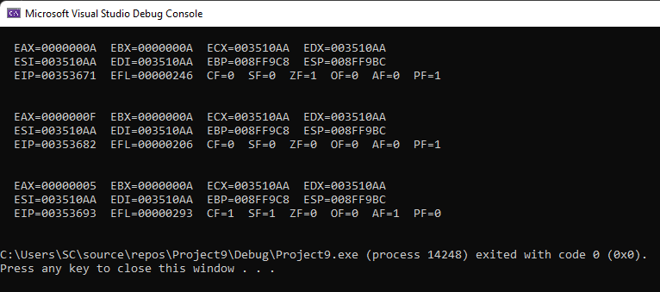
Figure 1: Output of Code – 01

JUMP Instructions

In assembly language, jump instructions are used to change the normal sequential flow of a program. Unlike high-level languages that provide constructs such as if-else, while, and for, assembly language relies on jump instructions to achieve decision-making and repetition.

When a jump instruction is executed, the Instruction Pointer (IP/EIP) is modified so that execution continues from the target location (label) instead of the next sequential instruction.

Types of Jump Instructions

Jump instructions are broadly divided into two main types:

- Unconditional Jump Instructions
- Conditional Jump Instructions Unconditional Jump Instructions
An unconditional jump always transfers program control to the target location, without checking any condition.

Syntax:

JMP destination

Execution always continues from the specified destination label. Example:
mov eax, 10 jmp Target
mov eax, 20 ; this instruction is skipped

Target:
mov ebx, 30
Here, the instruction mov eax, 20 is never executed because the control jumps directly to the label Target.

Conditional Jump Instructions

- A conditional jump transfers control only if a specific condition is true.
- If the condition is false, execution continues with the next sequential instruction.

Syntax:

Jcond destination

where Jcond is the jump condition mnemonic (e.g., JE, JNE, JC). Conditional jumps are usually executed in two steps:
- A condition is tested (using CMP, TEST, or arithmetic operations).
- Based on the flags set, the program either jumps to the specified label or continues sequentially.

The following program demonstrates Unconditional jump:

CODE – 02 [Demonstrate Unconditional Jump]
INCLUDE Irvine32.inc
.data
msg1 BYTE "This is the first message",0 msg2 BYTE "This is the second message",0

.code
main PROC
; Print first message
mov edx, OFFSET msg1 call WriteString
call Crlf
; Unconditional jump to skip printing msg2 jmp SkipSecondMessage

; This part will be skipped mov edx, OFFSET msg2 call WriteString
call Crlf

SkipSecondMessage: exit
main ENDP END main
Explanation of Output

  - jmp SkipSecondMessage → unconditionally transfers control to the label SkipSecondMessage.
  - The code between jmp and the label never executes (msg2 won’t be printed).
  - Demonstrates that unconditional jump does not check conditions, it always jumps.
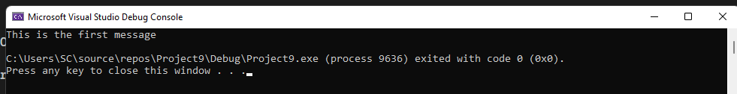

Figure 2: Output of Code – 02

Loop Instruction

In assembly language, loops are used to execute a block of instructions repeatedly. Unlike high- level languages that provide constructs such as for, while, or do-while, assembly language implements repetition using loop instructions.

The most common counter register used for loops is CX (16-bit) or ECX (32-bit). The loop instructions automatically decrement CX/ECX and check its value to decide whether to continue looping or exit.

Syntax

LOOP destination

Working of LOOP Instruction

- The LOOP instruction decrements CX/ECX by 1.
- If CX/ECX ≠ 0, control jumps to the specified label (destination).
- If CX/ECX = 0, execution continues with the next instruction after the loop.

Thus, the number of iterations is controlled by the initial value loaded into CX/ECX.

Simple LOOP Example

This program prints numbers from 1 to 5 using the LOOP instruction:

Output:
INCLUDE Irvine32.inc

.data
count DWORD 5

.code
main PROC
mov ecx, count ; set loop counter mov eax, 1 ; starting number

L1:
call WriteInt ; print value of eax call Crlf
inc eax ; increment number
loop L1 ; decrement ECX and jump if not zero

exit
main ENDP END main
1
2
3
4
5

NESTED LOOP

Simple NESTED LOOP Example
INCLUDE Irvine32.inc
.code
main PROC mov eax, 0
mov ebx, 0 mov ecx, 5 L1: inc eax mov edx, ecx call dumpregs
mov ecx, 10 L2:
inc ebx call dumpregs loop L2
mov ecx, edx loop L1 call DumpRegs exit
main ENDP
Procedures in Irvine Library

Clrscr
  - Clears the console screen and places the cursor at the top-left corner.
  - Registers Used: None.

Crlf
  - Prints a newline (carriage return + line feed) on the console.
  - Registers Used: None.
9

WriteBin
  - Prints the value in EAX as an unsigned 32-bit integer in binary format.

WriteChar
  - Prints the AL register’s content as a single character.

WriteDec
  - Prints the value in EAX as an unsigned 32-bit integer in decimal format.

WriteHex
  - Prints the value in EAX as a 32-bit integer in hexadecimal format.

WriteInt
  - Prints the value in EAX as a signed 32-bit integer in decimal format.

WriteString
  - Prints a null-terminated string from memory.
  - Registers Used: EDX = OFFSET String.

ReadChar
  - Waits for a single keypress and returns the character in AL.

ReadDec
  - Reads an unsigned decimal number from the keyboard and returns it in EAX.

ReadHex
  - Reads a hexadecimal number from the keyboard and returns it in EAX.

ReadInt
  - Reads a signed decimal number from the keyboard and returns it in EAX.

ReadString
  - Reads a string from the keyboard.
  - Registers Used: EDX = OFFSET Buffer, ECX = SIZEOF Buffer.

Delay
  - Pauses execution for the time given in EAX (milliseconds).

Randomize
  - Seeds the random number generator with system time.

DumpRegs
  - Displays the contents of all major registers: EAX, EBX, ECX, EDX, ESI, EDI, ESP, EIP, EFLAGS.

DumpMem
  - Displays a block of memory in hexadecimal format.
  - Registers Used: ESI = Starting OFFSET, ECX = Length, EBX = Type.

GetDateTime
  - Returns the current system date and time.

GetMaxXY
  - Gets console buffer size.
  - Registers Used: DX = Columns, AX = Rows.

GetTextColor
  - Returns current text color.
  - Registers Used: AL = Foreground, AH = Background.

Gotoxy

  - Moves cursor to specified row and column.
  - Registers Used: DH = Row, DL = Column.

MsgBox
  - Displays a message box with a string and title.
  - Registers Used: EDX = OFFSET String, EBX = OFFSET Title.

MsgBoxAsk
  - Displays a Yes/No pop-up question.
  - Registers Used: EDX = OFFSET String, EBX = OFFSET Title.
  - Return: EAX = 6 (Yes), EAX = 7 (No).

SetTextColor
  - Sets text color for console output.
  - Registers Used: EAX = Foreground + (Background * 16).

WaitMsg
  - Displays a message and waits for Enter key press.

